SN | Task | Remark
1 | User’s registered under Different Business should be directed through – URL Paysecure247.com (at present it is done at url fairplayofficial.com | This will be resolved at the time of final delivery
2 | Give all websites different designs with own home page content. So that it would’t appear that all the 3 domains are run under same project. That’s why we have taken different domain names for each segment. | Main Domain addresses need some work…pls check
3 | In investor panel when an Investor logins for the first time in ask him to choose a plan 25k/50k/75k/1 lac/ 2 lac etc. Purpose of choosing a plan is just that he can make a withdrawal request after completion of plan target. Now he can start making payments (investments). Every time he login at portal show him window to invest and complete his target. He will first choose amount and accordingly best options will appear to him for payment (choosen payment will not be visible to other investor for next 7 minutes (keep this dynamic controllable by admin panel). This is done to to give time to investor to complete his payment. After completion of stipulated time the locked payment will be available to other users/Investors. | This point is revised pls pay attention
4 | How admin will be identify that a particular user is registered under which business?? At present this is not visible to me in admin panel and user panel. | Resolved
5 | I have just registered a user under business name “Mahavir” by the name Raju dummy as user but it is not visible under that business to me. | Resolved
6 | I have made a widrawal request from rajudummy request reached successfully to “Mahavir” business and business is able to approve it as well. But problem is how business will identify that he is his user or not ?? Allow business to set or allocate some code for his users so that business can easily identify. | Resolved
7 | Remove this word P2P from everywhere on platform. Please replace it by Platform Payment. | Resolved
8 | Don’t allow user to cancel withdrawal request submitted by him. A request needs to cancelled by Concerned business or admin only. Give user a time tat of 2 minutes with timer (dynamic which will be set by admin) so that user can cancel/edit it within that time frame only. Once the time TAT is over only then send his this request to business for approval and once the request is approved by business then user cannot cancel the widrawal request don’t show user cancel button after TAT is over. Apply this for investors withdrawal requests also. And give a note to user/investor that once request is approved it cannot be edited/deleted. | Resolved
9 | When a investor accepts any withdrawal for making payment show him stop watch clearly stating that if any payment is submitted after time over it will not be Valid/Accepted. ( show him timer of 5 minutes to submit the request but in backend don’t show the particular payment (widrawal) to any one for atleast 7 minutes. | Resolved only 5/7 minute system is to be verified from Developer
10 | Whenever user/investor gives his upi id please system to convert it to scanner/QR code as well. | Resolved
11 | Ticket raised by user is visible to admin but it is not showing to concerned business please check. | Resolved
12 | Investor has paid full amount (Rs 10,000)of withdrawal request of a business user but in notification to user to says partial payment received- but this is complete payment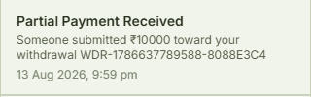 | Not resolved showing under split payment
13 | 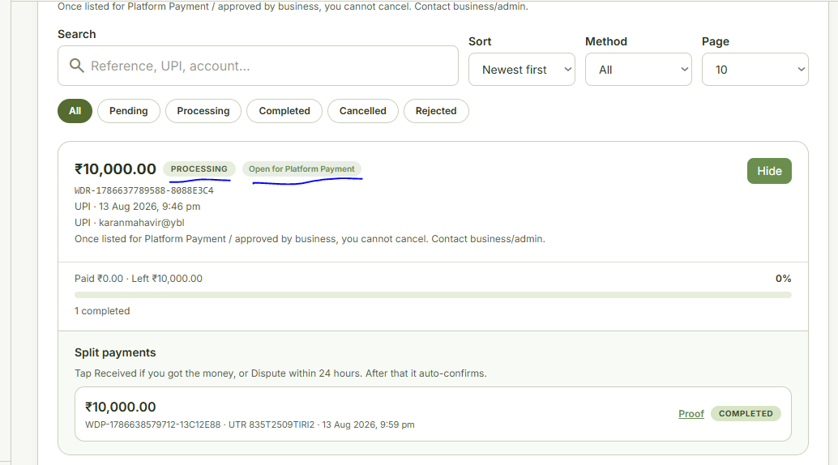 | Why full payment showing under split payment …pls check
14 | When a Investors raise a request for Withdrawal he is getting option to enter additional notes in UPI/BANK/USDT…remove this note box in all three modes. It may be used by investor to send any other unwanted information. | Resolved
15 | In User/Investor withdrwal forms Customise the fileds Like  Name Field should allow to enter Alphabets and Space and no numeric should be allowed,  UPI id filed should not allow more than 9 consecutive numeric characters in it, -NOT RESOLVED YET  Account Number filed should allow only numeric characters,  IFSC code filed should allow both alpha numeric characters it has total 11 characters first 4 characters are alphabets 5th character is Numeric “zero”next 6 charaters are alpa numeric - NOT RESOLVED YET  Bank Name should be Complusory at present it is optional
16 | When a User/Investor enters details for withdrawal show these detail once again before final submission so that he can verify the details. After submission also show him these details so that he can decide if he has to cancel the request ( NAME,IFSC CODE, ACCOUNTNo, BANK name) | Resolved
17 | User withdrwal details like NAME,IFSC CODE, ACCOUNT No, BANK name or UPI id should be clearly visible to Business as well to decide whether to approve the request for reject it. | Resolved
18 | Can we implant any api etc to verify Bank details in system which can verify through Account Number name of Account holder?? | Pending for me
19 | Withdrawal is visible to Business but withdrawal details are not visible to Admin …then how would Admin will be able to take any action. Show details to admin as well. | NOT RESOLVED YET
20 | When a investor makes any payment as investment, it is hot showing in Admin panel..why it is so?? How will admin monitor the system , admin should have access to all the data and entries | NOT RESOLVED YET
21 | You received ₹5,340.00. “This unlocks the payer investment” and cannot be undone easily. Why these details are shown to user once he confirms that he has received the payment. | RESOLVED
22 | 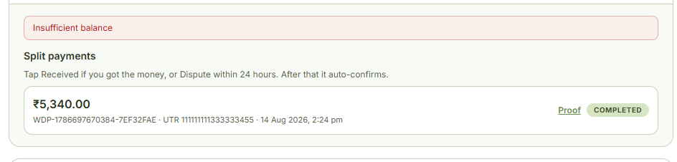  What is this insufficient balance warning to user once he received the payment | RESOLVED
23 | User 1 of Business has made a withdrwal request, this request is not available to user 2 of Same Business for Deposit. | RESOLVED
24 | Any withdrwal request by user remains visibile to him only till 2 minute (dynamic) time TAT. Once this TAT is over then it will be visible to his Business and once approved by Business then it sould be visible to Admin panel as well and all other concerned parties for making deposit to his withdrawal request. At present it is visible to Business , Admin & Investors during this 2 minute time TAT. | RESOLVED
25 | Withdrawal request raised by user of business 1 and paid by user of business 2. This transactions is not appearing in appearing in user login of business 2 till the time user of business 1 accepted it. Why it is so…he should have knowldege about the status of deposit has made from very beginning. Further to note that business 2 also doesn’t have any knowledge about this transaction neither before acceptance nor after acceptance | RESOLVED
26 | In Complete Model commission is charged from Business for there user’s deposit/witdrawal by admin panel . We don’t have to charge or Commision on widrawal or deposit from users. At present I am able to see Commision entries in ledger of users of business. (Rate of commision to be charged from business is controlled by admin panel and keep the rates dynamic so that these can be adjusted at any point of time in future)  Admin Panel will Give Commision to Investor on Deposits and widrawals only after sucessful completion of there target plan we will added up the commission in there wallet which can be widrawn by investor only after Successful completion of target amount/plan. (Rate of commision to be given to investor is controlled by admin panel and keep the rates dynamic so that these can be adjusted at any point of time in future) | NOT YET RESOLVED
27 | Web logins should be mobile user friendly | NOT YET RESOLVED
28 | Each page in plaform should refresh in 10 seconds along with refresh button to refresh manually | NOT YET RESOLVED
29 | Give option to withdraw/deposit fund in system to Admin and Businesses | NOT YET RESOLVED
30 | Showo option to see passowrd to everyone in plaform so that he can see the actual passowrd he is entering incase he is entering wrong passowrd along with option to reset the passoword. Google Authenticator Not yet Active …………… | PARTLLY NOT YET RESOLVED
31 | Minimum deposit/withdrawal should be Rs 300 for everyone in system. Keep this dynamic so that admin can change this it accordingly for every entity as per need. THIS RULE IS FOR COMPLETE PAYMENTS AND NOT FOR SPLIT PAYMENTS | NOT YET RESOLVED
32 | (FOR USER’S)- DEPOSITS  For making deposit on platform USER should first enter Amount he wants to deposit and then accordingly show him suitable UPI/QR/ACCOUNT DETAILS which he chooses for making payment for that amount on FIFO BASIS.  -First of all settlement should be done through any available withdrawal of business users  -Try and show details of matching amount first if available  - If details of matching amount not available then show him multiple details.  - IF business withdrawals not available then show investors details to user for making payment with same rules as given for deposit though business withdrawls | NOT YET RESOLVED
33 | (FOR INVESTOR’S)- DEPOSITS  For making deposit on platform INVESTOR should first enter Amount he wants to deposit and then accordingly show him suitable UPI/QR/ACCOUNT DETAILS which he chooses for making payment for that amount on FIFO BASIS to business withdrawls.  -Settlement should be done through any available withdrawal of business users  -IF business withdrawals not available then show alert to to INVESTOR to wait for sometime and as soon as any withdrawal comes from business users show some pop up on his phone screen so that he can become active. | NOT YET RESOLVED
34 | (FOR BUSINESS’S)- DEPOSITS  For making deposit on platform BUSINESS should first enter Amount he wants to deposit and then accordingly show him suitable UPI/QR/ACCOUNT DETAILS which he chooses for making payment for that amount on FIFO BASIS to business user’s/investors withdrawls.  -FIRST of all Settlement should be done through any available withdrawal of business users and then investor’s withdrawals  -IF withdrawals not available for making deposit then show alert to to CONCERNED BUSINESS to wait for sometime and as soon as any withdrawal comes from business user/Investor show some pop up on his phone screen so that he can become active to make deposit. | NOT YET RESOLVED
35 | (FOR ADMIN’S)- DEPOSITS  For making deposit on platform ADMIN should first enter Amount he wants to deposit and then accordingly show him suitable UPI/QR/ACCOUNT DETAILS which he chooses for making payment for that amount on FIFO BASIS to business user’s/investors withdrawls.  -FIRST of all Settlement should be done through any available withdrawal of business users and then investor’s withdrawals  -IF withdrawals not available for making deposit then show alert to to ADMIN to wait for sometime and as soon as any withdrawal comes from business user/Investor show some pop up on his phone screen so that he can become active to make deposit. | NOT YET RESOLVED
36 | Withdrawal – Rules  - Withdrawal request options is to be given to all the parties on platform ( admin,business,investor and user)  - NO one is allowed to raise widrawal request incase amount of withdrawal exceeds his actual withdrawal balance in system. | NOT YET RESOLVED-
37 | Incase of upi withdrawal/deposit – allow everyone to enter upi id or upload scanner , don’t allow to enter both. Incase individual decid  - Incase individual uploads scanner and is readible by system then don’t allow him to enter UPI manually.  - Incase individual enters upi id and is readible by system then don’t allow him to upload scanner manually.  - Give option to admin to enable/disable 9 consective numeric digits in upi filed for each business and investors | NOT YET RESOLVED-
38 | Sub admins are required for each business as well so that they can manage and assign individuals for performng tasks | NOT YET RESOLVED-
39 | In Support tickets give option to upload images and documents through phone storage or directly clicking through camera. | NOT YET RESOLVED-
40 | In ledger of all the parties on platform show all the deposit, withdrwals, commission,adjustments and charges with closing balances for reconcilation | NOT YET RESOLVED-
41 | Referral Plan/Scheme is missing for Investors in platform- please activate that as well | NOT YET RESOLVED-
42 | Payment confirmations should reach concerned person though whatsapp as well along with proof of payment upload on system by other party on platform for all users | 1 rupees per day for one customer for 24 hours. We will have to provide KYC AND GST this.
43 | Give option to all to save withdrwal details in his profile, so that he doesn’t have to enter the details each time. Primary account selected by entity will come as default whenever we will raise a withdrawal request . from the saved details he can choose in which account he wants withdrawl. Also allow to edit/ delete payment withdrawal details in his profile | NOT YET RESOLVED-
44 | Intergrate some apk to Verify Name of Account holder through Account number and ifsc for everyone is system | I have to find some API provider who can provides such service
45 | All reports should be downloadable in CSV OR PDF FORMAT by business and admin | NOT YET RESOLVED-
46 | ALLOW to attach payment proof from files as well when someone attachs payment proof at the time of deposit. At present he is getting option to click through camera only in mobile | NOT YET RESOLVED-
47 | Redirect the user to make a payment though phonepe /gpat/paytm/ other platforms as well incase he wants to pay though them | NOT YET RESOLVED-
48 | Give option to business to mark any particular withdralwal as priority. In this case marked transaction will over ride the fifo method and will be displayed first for withdawal. But do this for his business only it should not over ride transaction rules of other business. | Will do it later once system is ready. Here we will give monthly limit to business for n number of transactions.
49 | Give option to super admin to enable/disable transaction between any particular business with respect to deposit or withdrawal. | NOT YET RESOLVED
50 | Give priority to settle rcpts and payments through business 2 business entries first. Give option in super admin panel to enable or disable this function. | NOT YET RESOLVED
51 | In Deposit/withdrawal give CDM option as well. So that Customer can deposit cash as well in case he wants. Is case of CDM we will have to give more time I think to details remain not visible on platform which he as chosen for deposit.- assign to other person wala option decide howa tha ismai | NOT YET RESOLVED
52 | Audit Trails: Every single action (who approved a payment, who edited a user profile, what time a deposit came in) must be logged permanently. No one—not even the client—should be able to delete a transaction history. Allow Super Admin to delete data of a particular business for a particular period.
53 | Admin should have option to enable/ Disable partial withdrwal/deposit option for any class of entity. Like a particular Investor/User/Business. | NEW POINT
54 | 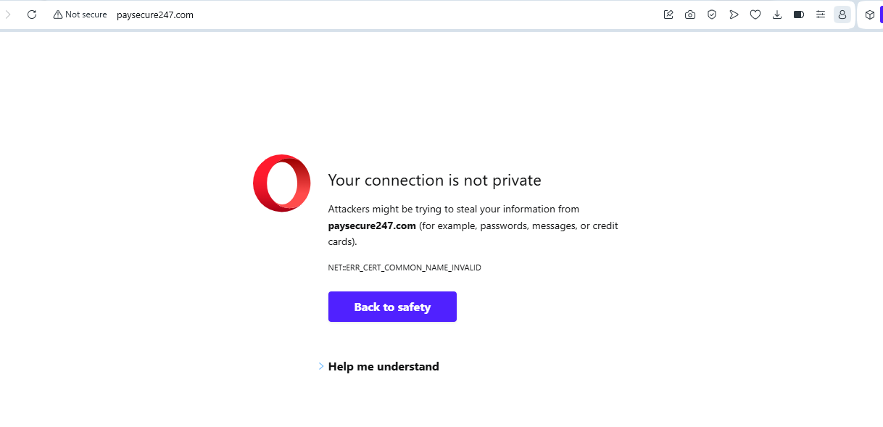Why getting this message on domain ?? | NEW POINT
55 | 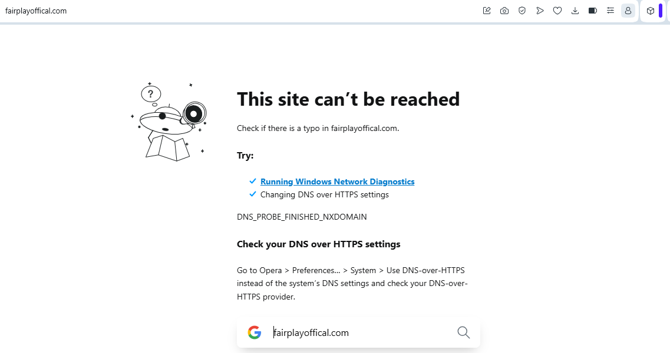Main Page of Domain is showing this error…please fix this. | NEW POINT
56 | 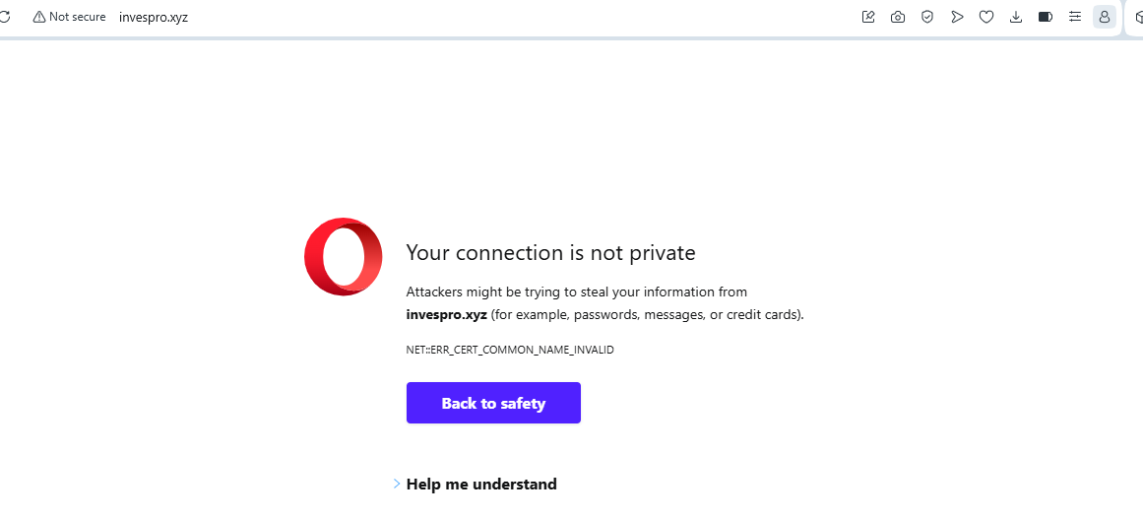Please fix this as well | NEW POINT
57 | Make it mandatory to have mobile number entered at the time of registration for eveyone is system | NOT YET RESOLVED
58 | 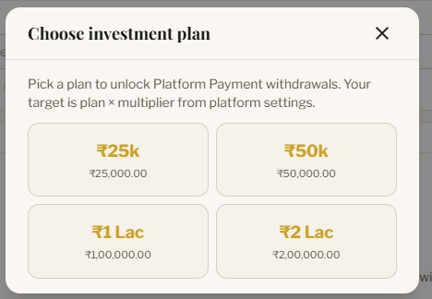  This is the first time login after a investor gets registered on Investor Portal.  In this page change the text to “Choose an Investment plan to unlock Earnings. | NEW POINT
59 | 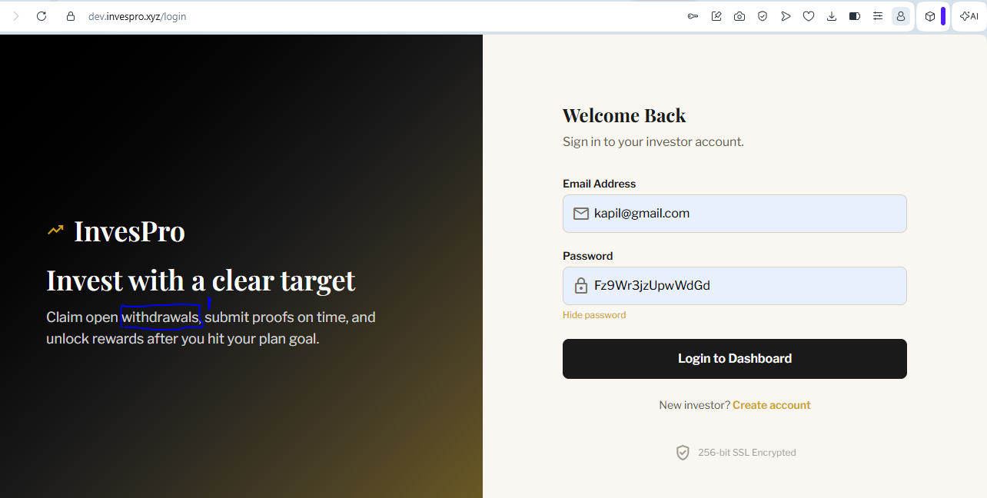  Replace the text withdrawals by Investment. This is the Screenshot of login page of Investors portal | NEW POINT
60 | Name of User/Business/Investor should/Admin Should always appear to them at their respective portals. | NEW POINT
61 | When a user raises ticket no notifications/alert is received by business/admin to take action unless admin/business visits support section. Please do something about it. Further ticket should contain the credentials of sender so that we can verify the details. Contact details of every user should be visible to Super Admin and not Sub Admins | NEW POINT
62 | What is the Time Frame decided in system for Auto Verification of Payments incase payment is not confirmed by receiver.?????? | NEW POINT
63 | 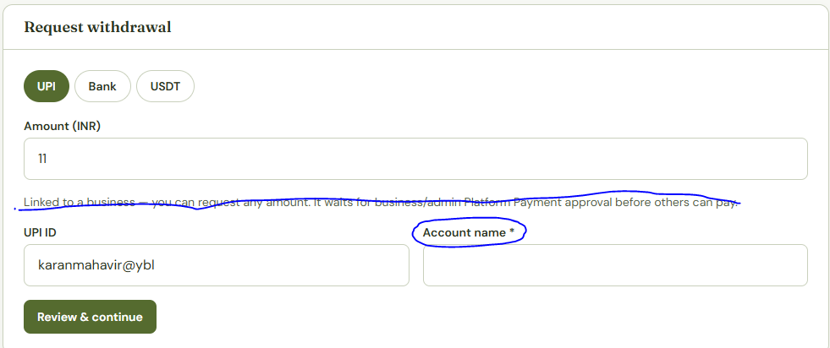  This is the SS of user withdrawal request. Remove stricked out text line.  Circled Text Should be properly written as “ Name of Account Holder” | NEW POINT
64 | 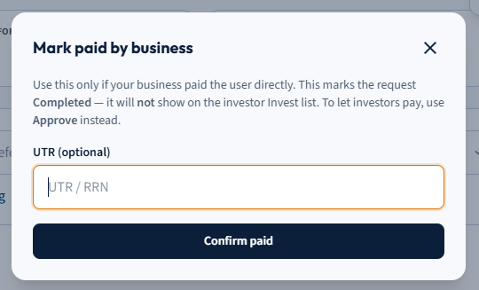  Give option to upload supporting Evidence of payment as well. This is the SS of Business Withdrawals sections where transaction is Paid by Business. | NEW POINT
65 | 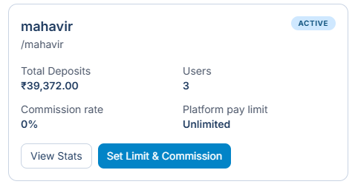Explain how to set limit and Rules for charging Commision by admin from Business | NEW POINT
66 | 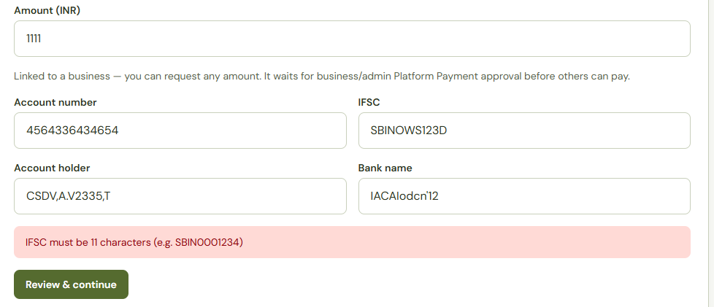NOT GIVING PROPER ERROR MESSAGE FOR INCORRECT IFSC CODE 5 CHARACTER SHOULD BE ZERO IN THIS CASE.  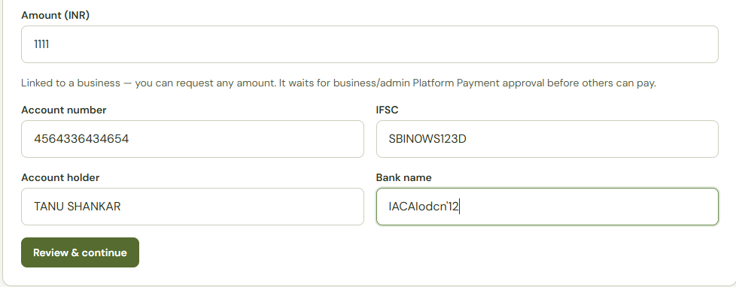Bank Name should not contain numeric characters | NEW POINT
67 | Deposits by users and investors are not showing in in any of the platforms namely Admin and business | Not yet resolved
68 | Give option to reset the transaction data of any entity namely investor/user/business | NEW POINT
69 | BUSINESS REGISTRATION mai mobile number Compulsory hona chaiye system abhi bhi without mobile number register kar raha hai ..please fix this. Also please don’t allow anyone in system to register in system with same mobile number next time.
70
71 | 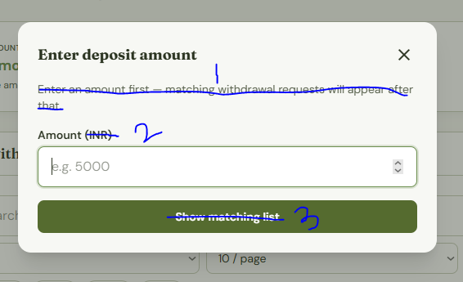  This is the Deposit Screen in User Platform  1. Remove stricked off text as mentioned in highlited point 1.  2. In marked point number 2 remove the TEXT INR, only Keep the Text Amount.  3. Replace the Quoted text “Show Matching List” by Text “SUBMIT”  4. Show minimum Amount (300)that can be deposited by User – For this i have shown you a screenshot below. (This Minimum Amount may Change from Business to Business. So given option option to each business to Set this Amount from its respective Business Panel)  5. Insert amount buttons like 500/1000/1500/2000/4000/5000 as well so that user can choose amount instead of manually entering as well. Now he has both the options to enter the amount manually or by choosing pre defined amount buttons – You can refer below sccrenshot shown below  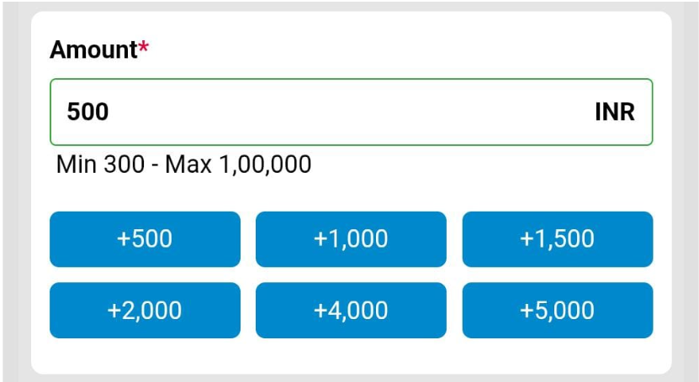
72 | 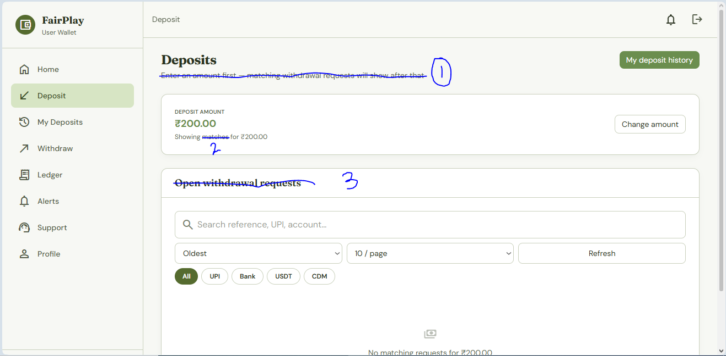  - Remove this line.  - Replace the Quoted text “matches” with text “Payment Details”  - Replace the Quoted text “Open withdrawal requests” with text “Available Details for Payment”
73 | 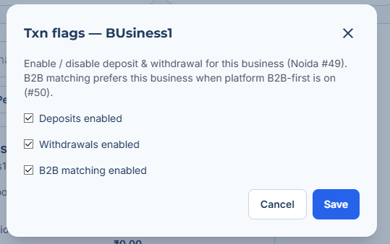  This is the Txn Flag assigned to Each Business under Admin Panel. Ismai Noida#49 and #50 kya hai?? Also please explain its usage so that we can use it properly.
74 | 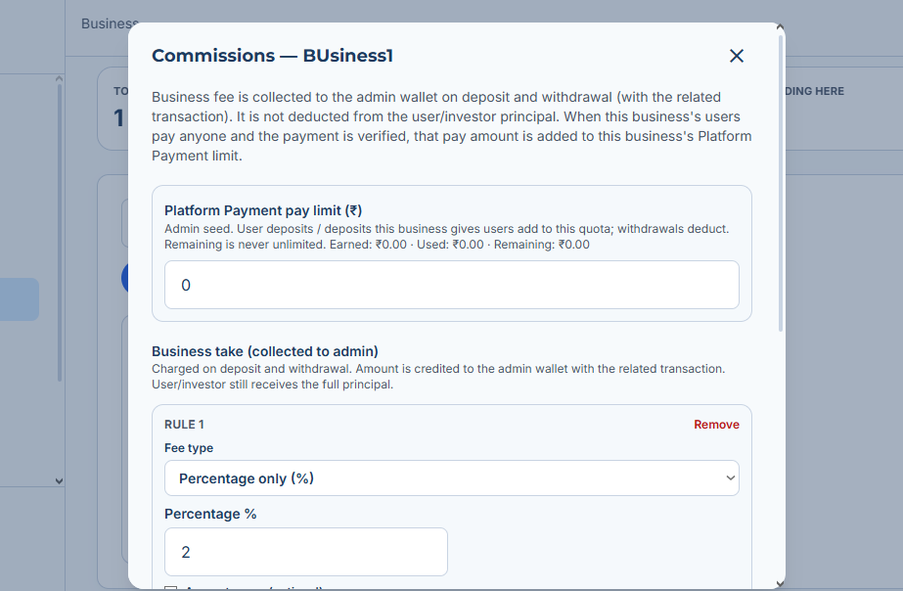  This is Commision adjustment page of a particular business in Admin Panel. Please explain how it works. Also Rate of Commission on Deposit may Differ from Rate of Commission on Withdrawal of the Same business. Please give option to assign separate buttons for deposit & withdrawal Commission so that we can adjust it accordingly in Admin Panel for Business.
75 | 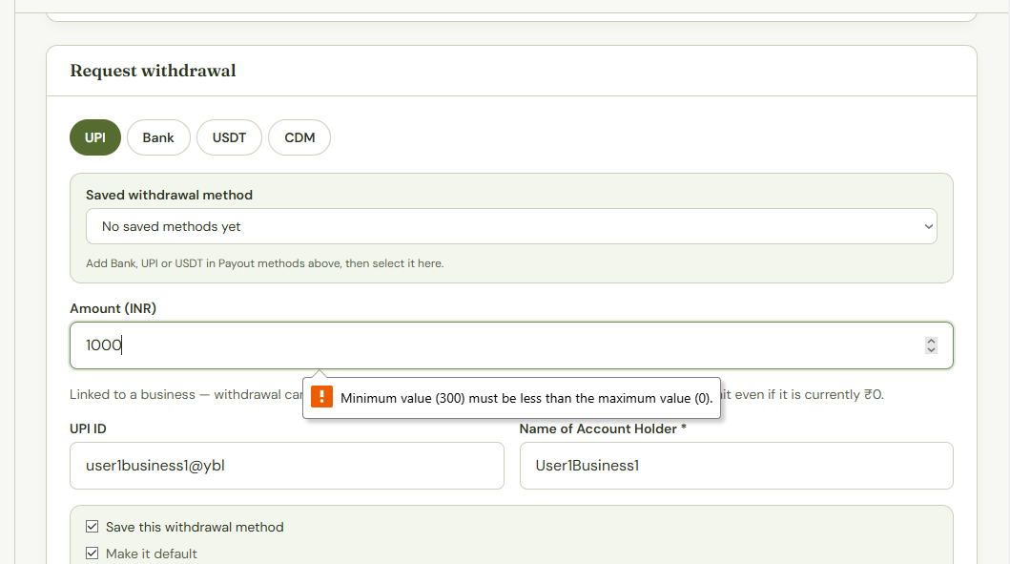  User is unable to make a withdrawal request of Rs 1000. Pay limit of Business is set at Rs 10,000. Please check this problem.
76 | 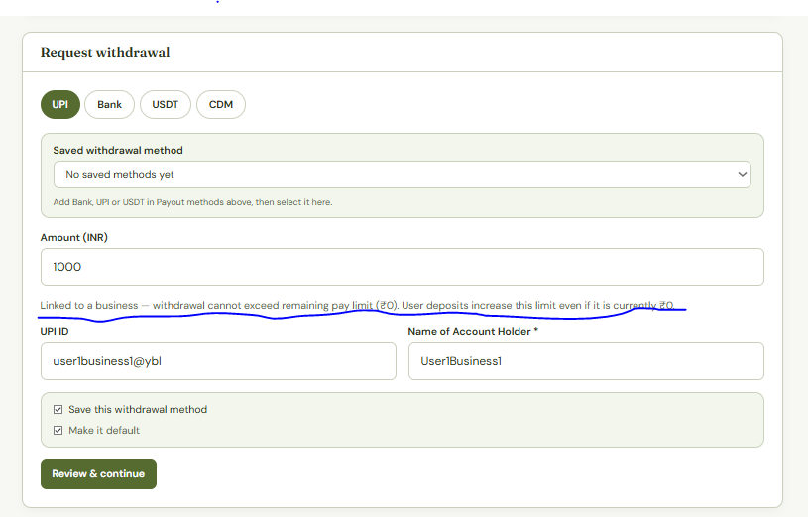  This is the Screenshot of Withdrwal page of user. Please remove Underlined line marked in Screenshot.

